**REPORT**

**Time Series Forecasting of Ultratech Cement**

**By**

**ROHAN SANKLECHA**

**SERIAL NUMBER 20**

**Under The Supervision Of**

**Dr. Nagaraju Thota**



**Birla Institute Of Technology And Science, Pilani**

**Hyderabad Campus**

**(DEC 2022)**

**FIN F414**

**FINANCIAL RISK ANALYTICS & MANAGEMENT**

**ACKNOWLEDGEMENT**

I would like to extend our heartfelt thanks to Dr. Nagaraju Thota, sir, for providing us with the chance for this project and for spending so much of his valuable time guiding us as needed. His contribution to the project through lectures, notes, and slides proved to be quite important. I want to express our gratitude to him for giving us this wonderful chance to put what we learned in class into practice and get first-hand knowledge. For all of his assistance and direction with this project as well as the course as a whole, I am grateful.





**ABOUT THE COMPANY**

**Nature of business**

India-based UltraTech Cement Limited is a firm that deals in cement and items connected to cement. Ordinary Portland Cement (OPC), Portland Blast Furnace Slag Cement (PSC), Portland Pozzolana Cement (PPC), white cement and white cement-based products, ready mix concrete, including specialty concrete, building products, such as aerated autoclaved concrete (AAC) blocks and joining mortars, and a host of other products are manufactured by the company and sold in retail formats. UltraTech Cement, UltraTech Concrete, UltraTech Building Products, Birla White Cement, and White Topping Concrete are among the company's offerings. Tile adhesives, repair materials (MICROKRETE and BASEKRETE), waterproofing products, industrial and precision grout, plasters (READIPLAST, SUPER STUCCO), and masonry products are all part of its UltraTech Building product line (FIXOBLOCK).

**Ownership Pattern**

Ultratech cement is a public limited company. Aditya Birla group holds the majority of the shares.

Promoters - 59.6% - Aditya Birla group

FII - 13.12%

DII- 17.04%

OTHERS - 23%

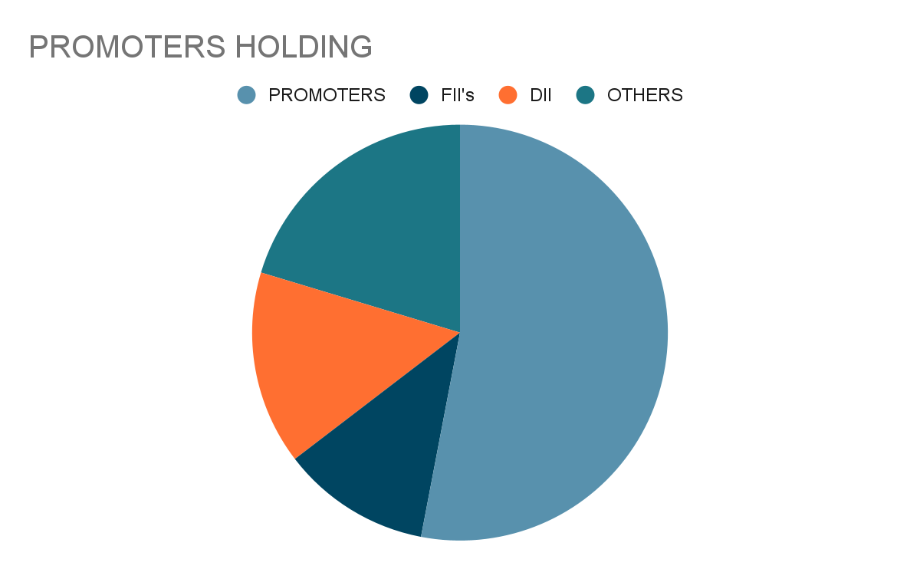

**Importance in Industry**

India is the world's second-largest cement manufacturer. It makes sense given that India's cement sector contributes significantly to the country's economy and directly or indirectly employs more than a million people. The Indian cement business has drawn large investments from both domestic and foreign companies since it was deregulated in 1982. The cement industry is anticipated to gain the most from India's potential for expansion in the infrastructure and building sectors. The sector is anticipated to receive a significant boost from some of the most significant recent projects, such the creation of 98 smart cities. Several international players, like Lafarge-Holcim, Heidelberg Cement, and Vicat, have recently made investments in the nation in anticipation of these changes and with the assistance of sensible government foreign policies. The readily available cement-making raw resources, such as limestone and coal, play a vital role in the sector's expansion.

**1.6 Board of directors:**

|  |  |
| --- | --- |
| **Mr.Kumar Mangalam Birla** | **Chairman** |
| **Mr.Ashish Dwivedi** | **Chief Executive Officer** |
| **Mr.Ramesh Mitragotri** | **Chief Human Resource Officer** |
| **Mr.Sujeet Jai** | **Chief Legal Officer** |
| **Mr.E R Raj Narayanan** | **Chief Manufacturing Officer** |
| **Mr.Vivek Agrawal** | **Chief Marketing Officer** |
| **Mr.Sanjeeb Kumar Chatterjee** | **Co. Secretary & Compl. Officer** |
| **Mr.Pramod Rajgaria** | **President** |
| **Mr.Sunil Duggal** | **Independent Director** |
| **Mr.K C Jhanwar** | **Managing Director** |

**DAILY RETURNS ANALYSIS**

**Estimation of Beta Using CAPM Model**

The CAPM model can be described as

**E(R) = Rf + Beta * (Rm -Rf)**

Where

● E(R) is the expected return of the firm

● Rm is the returns of the market

● Rf is the risk free rate

Beta can be estimated by running a regression model where the dependent variable y is the returns of the firm and the independent variable x is the returns of the market. The slope parameter estimated from the regression model is the beta of the CAPM model. Beta of a security tells us how sensitive the security’s returns are to the market's returns.

Returns were calculated for a daily basis from November 1st 2020 to 30st 2022 (2 years). The closing prices of the security is plotted in the graph shown below. The excess returns were calculated for the security as well as the index.

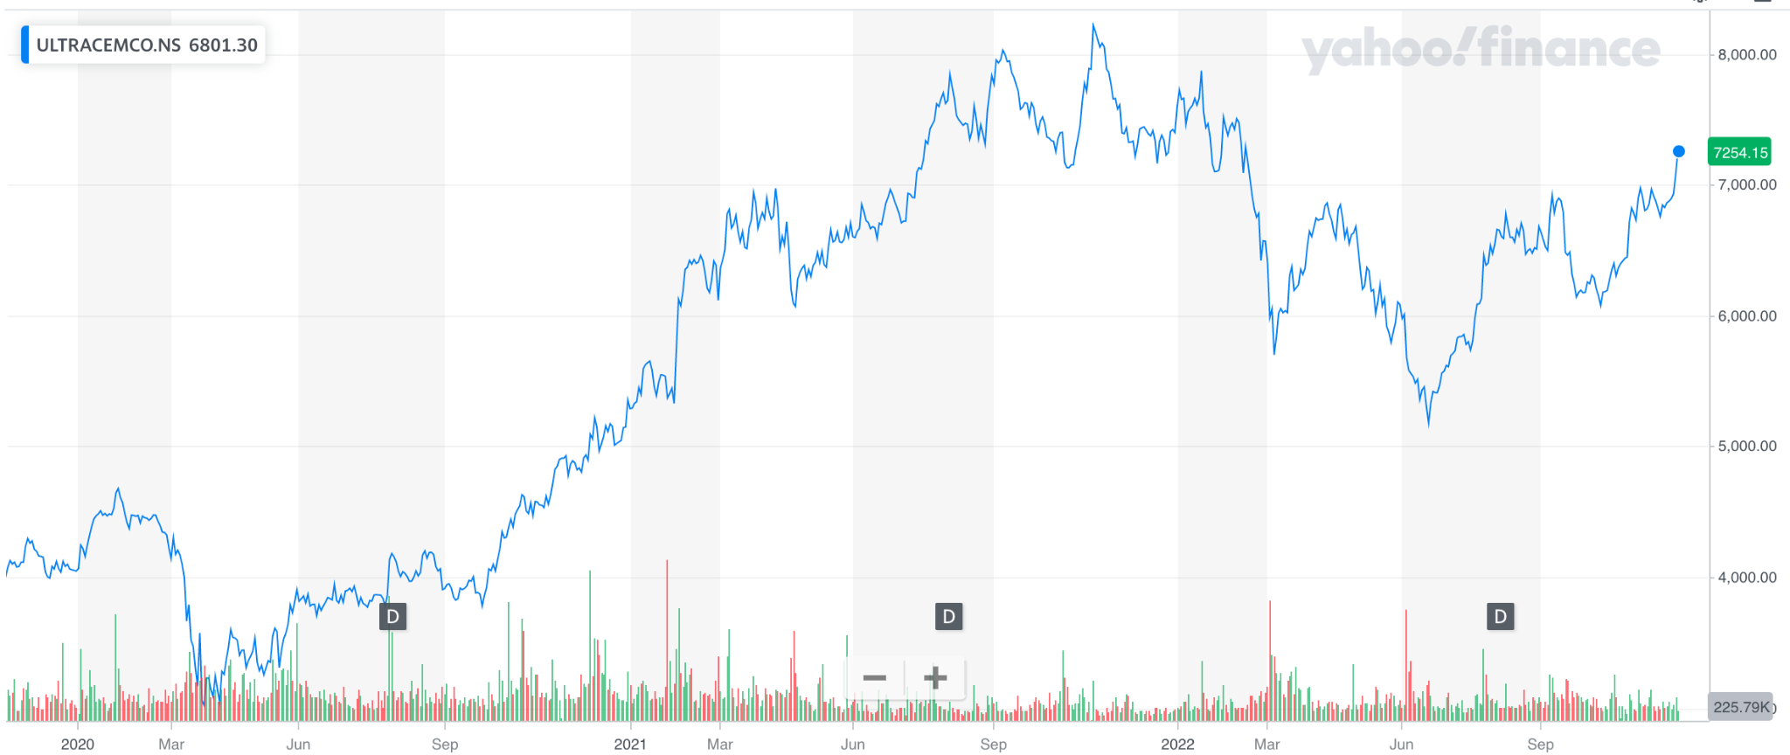

Daily Closing Prices for Ultratech cement

The returns of the security was calculated for the analysis period and the plot is shown in the figure below. Return distribution was a random walk and the returns oscillated between -10% to 10%.. There were some outliers present in between, where returns were -20% (End of April 2020) and 18% (December 2020).

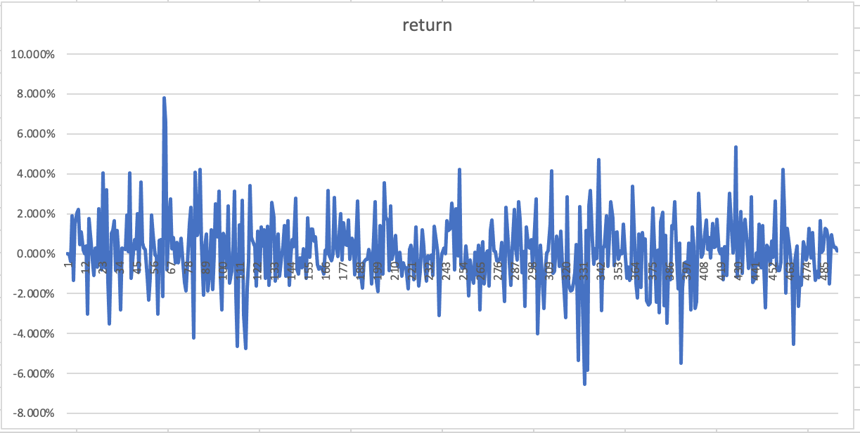

Daily returns of Ultratech Cement

A linear regression was done between the excess security returns as the dependent variable and excess market returns as the independent variable and the following results were obtained: 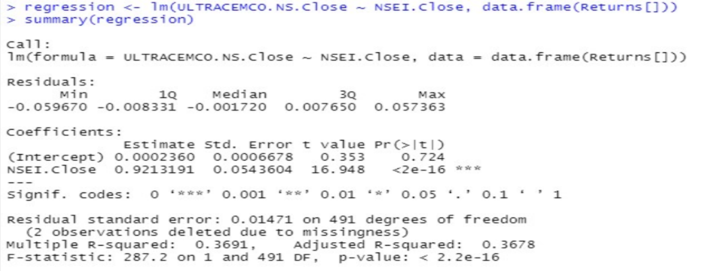 Regression statistics for Ultratech cement And NSEI

Slope of the regression was found to be 0.92 and intercept to be 0.00023. The p value of the slope is less than 0.01, which tells us that the slope of the regression is significant on a 99% Confidence Interval.

**Inference:** The beta of the stock is 0.92. This tells us that the security’s price is less volatile than the market as market beta is considered as 1. Security is less sensitive to macroeconomic factors than the market. If the market moves up by 1%, then this security will move up by only 0.92%.

**Estimating AR and MA Coefficients using ARIMA model.**

The AR and MA coefficients can be determined by running the ACF and PACF plots.



Daily returns of Ultratech cement

Mean and Variance of the returns were calculated. The mean was 0.00087 and variance was 0.0002​​. Since the mean is close to zero and variance seems constant throughout the analysis period, we ran an Augmented Dickey- Fuller test to check whether the series is stationary series or not. Results of the test are shown below:

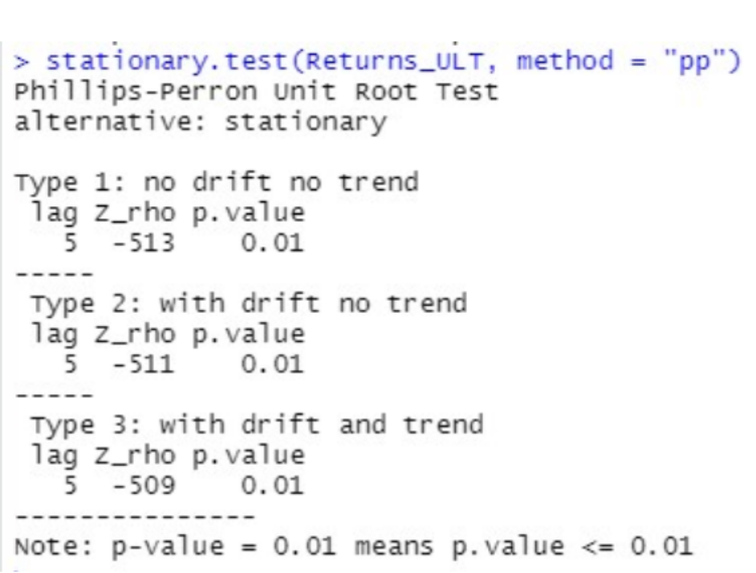

Augmented Dickey-Fuller Test for Ultratech cement Daily returns

The p value of this test is less than 0.05 which tells us to reject the null hypothesis.Therefore, for the Augmented Dickey-Fuller test, we can say that this series is a stationary series. The series is stationary, so it will satisfy the following properties:

● The mean E(yₜ) is the same for all t.

● The variance of yₜ is the same for all t

● The covariance and correlation between yₜ and yₜ₋₁ is same for all t

**ACF Plot**

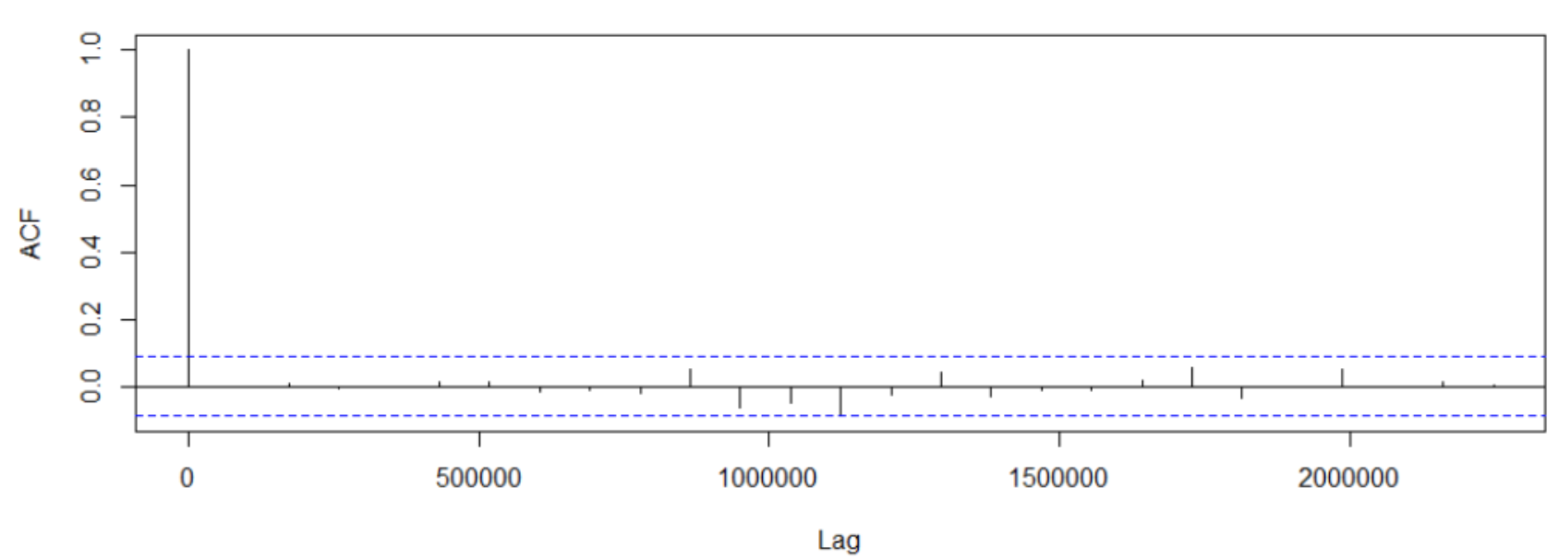

ACF Plot for Daily Returns of ultratech cement

The ACF property defines a well defined pattern for autocorrelation. From our graph, we can see that there is no significant spike. There is one spike at lag order 8, therefore we can say that the order of the MA model is zero. It is estimated as a MA (0) model.

**PACF Plot**

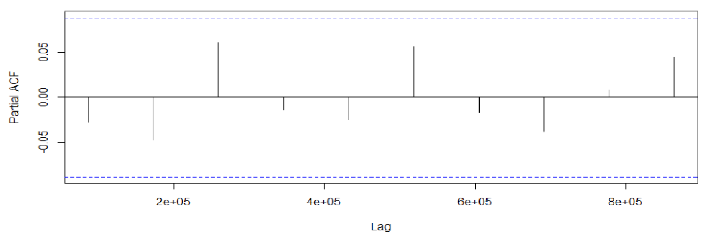

PACF Plot for Daily Returns of Ultratech cement

Number of spikes in the PACF indicate the suitable AR order.In PACF plot, the number of

spikes is not clear( does not show clear pattern) indicating that the AR model order is also 0.

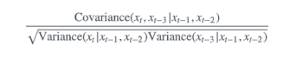

After this, we run the ARIMA test on all orders (p,d,q) which we might think would make a

good model. The best model is the one with the lowest AIC score. Using the ARIMA model

then we predict values for a small interval of time and evaluate the model

**Identification and interpretation of ARIMA model**

ARIMA models may include all or none of the autoregressive terms, moving average terms, and differencing parameters.

When no differencing is required the models can be expressed as ARIMA(p,0,q) type. In cases where the data are non-stationary, we need to incorporate the differencing factors. So in case of stock price modelling we may very need differencing but as returns are already a relative difference we are not likely to encounter differencing for modelling returns.

For daily returns data, from the ACF and PACF plots we have a MA(0) and AR(0) model. We ran the auto.arima() function to cross examine our results. The results we obtained from the auto.arima() function was that the model is AR(0) and MA(0) model.

Thus, the values that have been used for both p and q is zero.

Auto ARIMA results for Daily Returns of Ultratech cement

The results for the ARIMA model are presented below

ARIMA model test for Daily returns of Ultratech cement

The AIC value is - 2543.23.

The BIC value is - 2538.25

**Diagnostic Test**

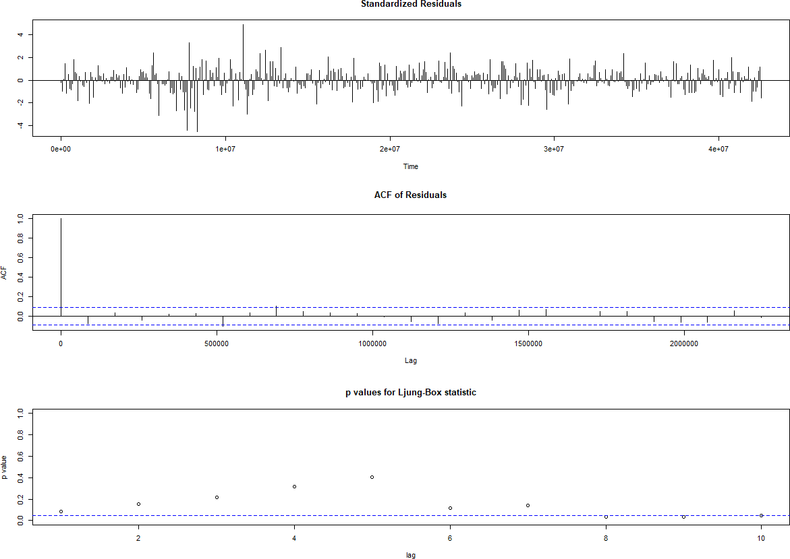

Diagnostic Model Test for Daily Returns of Ultratech cement

**Interpretation:**

Standardized Residuals of the model are randomly distributed.

• ACF of residuals is not significant for any value lag.

• The p-values for Ljung-Box are always greater than 0.05.

Therefore, we can conclude on the basis of the above three observations that the model is a good fit.

**Prediction using the ARIMA model**

Forecasted Returns Of ultratech cement using ARIMA model

This is something specific to a stable series. As already mentioned, historical data can lead to convergent future predictions only for stable data or for smoothened (differenced) data. The prediction interval has been decided by seeing when the forecast converges. This is because after running for some interval, the data series will converge at one value and the curve will stabilize.

**Forecasting Volatility using GARCH & EGARCH models**

We run the GARCH models again on the daily returns of Ultratech Cement.

GARCH model Specs for Daily Returns of Ultratech cement

From the above table we see that GARCH (1,1) is the most appropriate model and by default the mean model ARFIMA(1,0,1) is chosen.

We run the EGARCH models again on the daily returns of Ultratech cement.

EGARCH model Specs for Daily Returns of Ultratech cement

From the above table we see that EGARCH (1,1) is the most suitable model and by default the mean model ARFIMA(1,0,1) is chosen. These results are similar to what we observed for the GARCH model.

**Estimating the Model**

Diagnostic Test of GARCH model for Daily Returns of Ultratech cement

**Interpretation:**

● In GARCH, the variance tends to show mean reversion which means it gets pulled to a long-term volatility rate over time.

● The conclusion obtained from the weighted Ljung-Box Test shows us that there is no relationship between the residuals and this is a stable model.

● Here Omega, Alpha and Beta are obtained from estimated standard errors in the figure above.

**GARCH Model Forecasting**

We use the GARCH model for predicting volatility. Results are shown in the figure given below

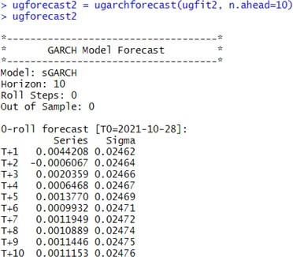

GARCH Model Volatility Forecast for Daily Returns of Ultratech cement

**WEEKLY RETURNS**

**Estimation of Beta Using CAPM Model**

The CAPM model can be described as

**E(R) = Rf + Beta * (Rm -Rf)**

Where

● E(R) is the expected return of the firm

● Rm is the returns of the market

● Rf is the risk free rate

Beta can be estimated by running a regression model where the dependent variable y is the returns of the firm and the independent variable x is the returns of the market. The slope parameter estimated from the regression model is the beta of the CAPM model. Beta of a security tells us how sensitive the security’s returns are to the market's returns.

Returns were calculated for a daily basis from 1st Nov 2020 to 31th Oct 2022. The closing prices of the security is plotted in the graph shown below. The excess returns were calculated for the security as well as the index.

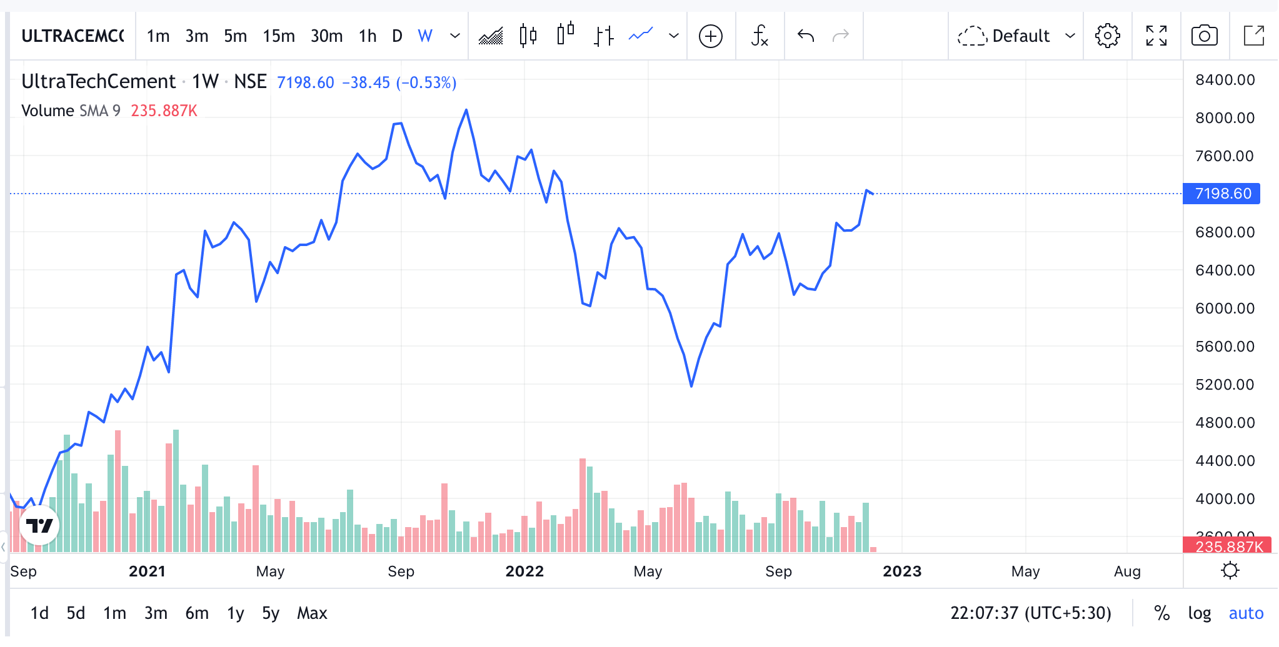

Weekly Closing Prices of ultratech cement

The returns of the security was calculated for the analysis period and the plot is shown in the figure below. 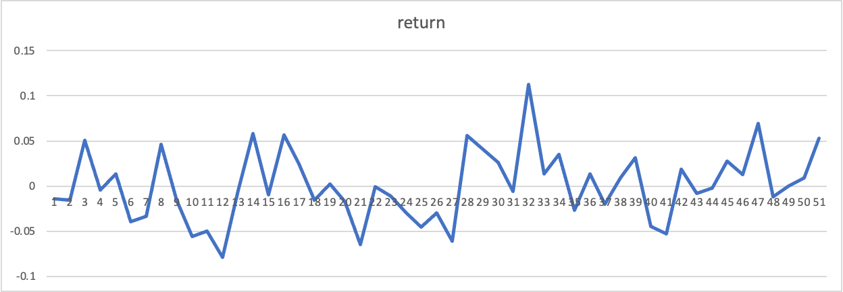 Weekly Returns of ultratech cement

A linear regression was performed between the excess security returns as the dependent variable and excess market returns as the independent variable and the following results were obtained:

Regression statistics for ultratech cement And NSEI

Slope of the regression was found to be 0.955 and intercept to be 0.00091. The p value of the slope is less than 0.01, which tells us that the slope of the regression is significant on a 99% Confidence Interval.

**Inference:** The beta of the stock is 0.955. This tells us that the security’s price is less volatile than the market. Security is less sensitive to macroeconomic factors than the market. If the market moves up/down by 1%, then this security will move up/down by 0.955%.

**Estimating AR and MA Coefficients using ARIMA model.**

The AR and MA coefficients can be determined by running the ACF and PACF plots.

. Since the mean is close to zero and variance seems constant throughout the analysis period, we ran an Augmented Dickey- Fuller test to check whether the series is stationary series or not.

Results of the test are shown below:

Results of ADF Test for Weekly Returns of ultratech cement

The p value of this test is greater than 0.05 which tells us that we fail to reject the null hypothesis. The series is non-stationary.

Since the series is found to be non stationary, therefore it will not follow the below properties: ● The mean E(yₜ) is the same for all t.

● The variance of yₜ is the same for all t

● The covariance and correlation between yₜ and yₜ₋₁ is same for all t

**ACF Plot**

ACF Plot for Weekly Returns of ultratech cement

The ACF property defines a distinct pattern for the autocorrelations.Since, the ACF is not significant for any value of lag, the order of the moving average model is zero. It is estimated to be a MA (0) model.

**PACF Plot**

PACF Plots for Weekly Returns of ultratech cement

Autocorrelation for all the lags are statistically unsignificant. This suggests a possible AR (0) model for these data. As can be seen from the graph above that the PACF is not significant for any value of lag, the order of the auto regressive model can be taken as zero. After this, we run the ARIMA model on all orders (p,d,q) which we think might make a good model and choose the best amongst them. The best model is that which has the least AIC value.

Using the ARIMA model then we predict values for a small interval of time and evaluate the model.

**Identification and interpretation of ARIMA model**

ARIMA models may include all or none of the autoregressive terms, moving average terms, and differencing parameters.

When no differencing is required the models can be expressed as ARIMA(p,0,q) type. In cases where the data are non-stationary, we need to incorporate the differencing factors. So in case of stock price modelling we may very need differencing but as returns are already a relative difference we are not likely to encounter differencing for modelling returns.

For weekly returns data, from the ACF and PACF plots we have a MA(0) and AR(0) model. We ran the auto.arima() function to cross examine our results. The results we obtained from the auto.arima() function was that the model is AR(0) and MA(0) model.

Thus, the values that have been used for both p and q is zero.

Auto ARIMA results for Weekly Returns of ultratech cement

The results for the ARIMA model are presented below

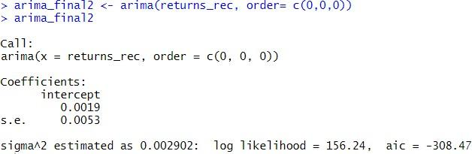

ARIMA model Test for Weekly returns of ultratech cement

We do not have any coefficients.

The AIC value is -346.51.

The BIC value is -333.34

**Diagnostic Test**

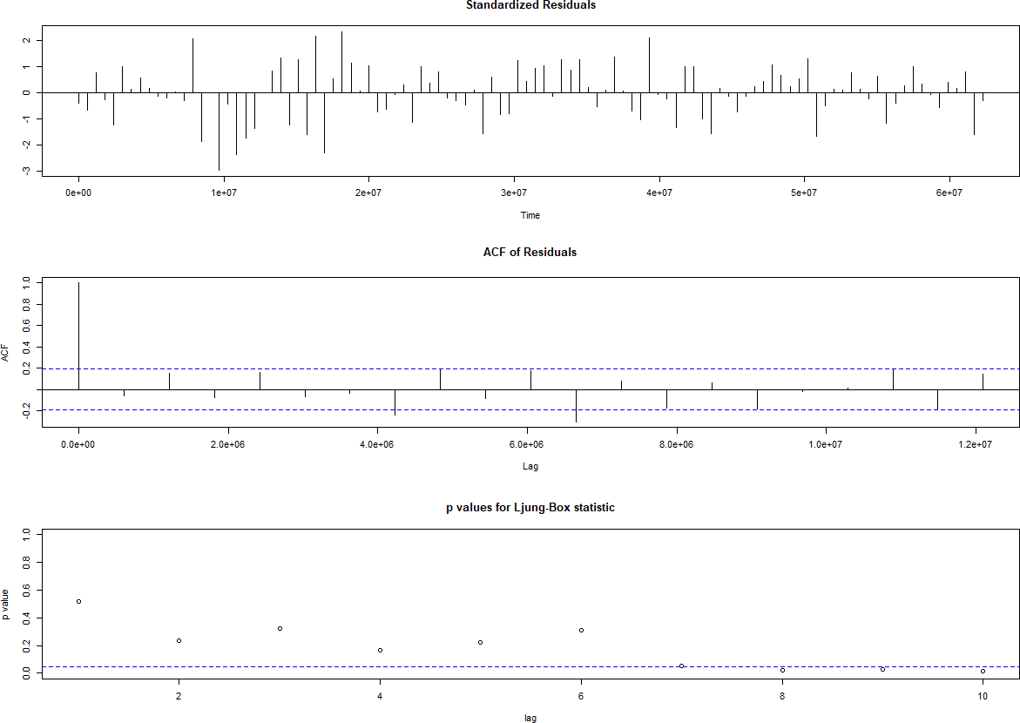

Diagnostic Test for Weekly returns of ultratech cement

**Interpretation:**

• Standardized Residuals of the model are randomly distributed.

• ACF of residuals is not significant for any value lag.

• The p-values for Ljung-Box is greater than 0.05 for first 2 lags

Therefore, we can conclude on the basis of above three observations that the model is a moderate fit.

**Prediction using the ARIMA model**

ARIMA model Forecast for Weekly Returns of ultratech cement

This is something specific to a stable series. As already mentioned, historical data can lead to convergent future predictions only for stable data or for smoothened (differenced) data. The prediction interval has been decided by seeing when the forecast converges. This is because after running for some interval, the data series will converge at one value and the curve will stabilize

The ARIMA Model was used to predict the return after the analysis period. The forecast given by the model is given above.

**Forecasting Volatility using GARCH & EGARCH models**

We run the GARCH models again on the daily returns of ultratech cement.

GARCH Model Specs for Weekly Returns of ultratech cement

From the above table we see that GARCH (1,1) is the most appropriate model and by default the mean model ARFIMA(1,0,1) is chosen.

We run the EGARCH models again on the daily returns of ultratech cement.

EGARCH Model Specs for Weekly Returns of ultratech cement

From the above table we see that EGARCH (1,1) is the most suitable model and by default the mean model ARFIMA(1,0,1) is chosen. These results are similar to what we observed for the GARCH model.

**Estimating the Model**

Diagnostic Test of GARCH Model for Weekly Returns of ultratech cement

**Interpretation:**

● In GARCH, the variance tends to show mean reversion which means it gets pulled to a long-term volatility rate over time.

● The conclusion obtained from the weighted Ljung-Box Test shows us that there is no relationship between the residuals and this is a stable model.

● Here Omega, Alpha and Beta are obtained from estimated standard errors in the figure above.

**GARCH Model Forecast:**

Now we use the GARCH Model to forecast volatility. The forecast are as follows:

GARCH Model Volatility Forecast for Weekly Returns of ultratech cement

**MONTHLY RETURNS**

**Estimation of Beta Using CAPM Model**

The CAPM model can be described as

**E(R) = Rf + Beta * (Rm -Rf)**

Where

● E(R) is the expected return of the firm

● Rm is the returns of the market

● Rf is the risk free rate

Beta can be estimated by running a regression model where the dependent variable y is the returns of the firm and the independent variable x is the returns of the market. The slope parameter estimated from the regression model is the beta of the CAPM model. Beta of a security tells us how sensitive the security’s returns are to the market's returns.

Returns were calculated for a monthly basis from 1st nov 2020 to 31st oct 2022. The closing prices of the security is plotted in the graph shown below. The excess returns were calculated for the security as well as the index.

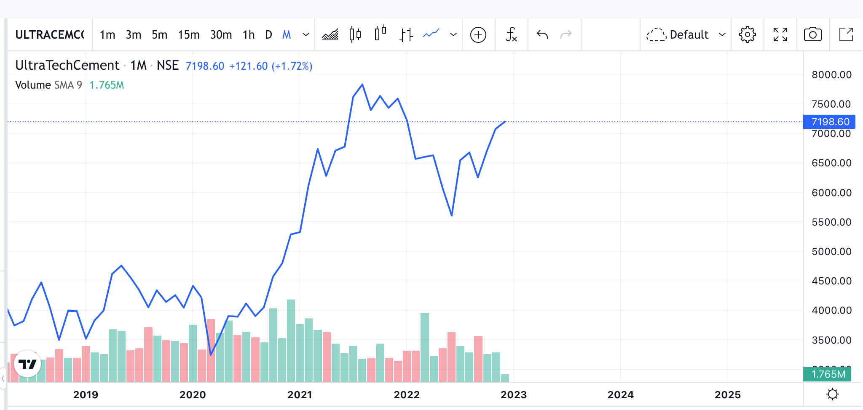

Monthly Closing Prices of ultratech cement

The returns of the security was calculated for the analysis period and the plot is shown in the figure below.

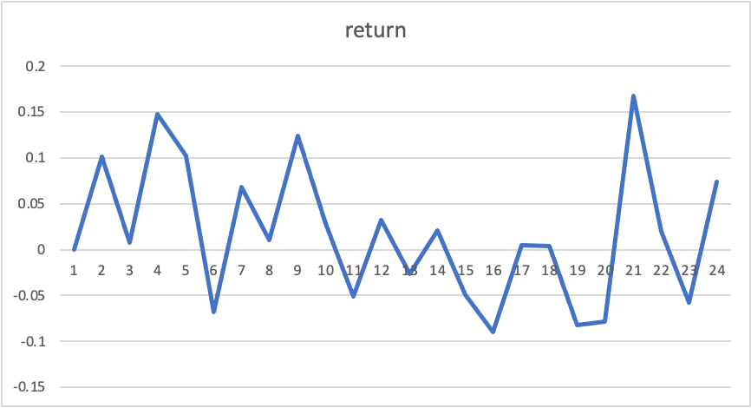

Monthly Returns for ultratech cement

A linear regression was performed between the excess security returns as the dependent variable and excess market returns as the independent variable and the following results were obtained:

Regression statistics for Monthly Returns of ultratech cement and NSEI

Slope of the regression was found to be 0.52 and intercept to be 0.016. The p value of the slope is less than 0.01, which tells us that the slope of the regression is significant on a 99% Confidence Interval.

**Inference:** The beta of the stock is 0.52. This tells us that the security’s price is less volatile than the market. Security is less sensitive to macroeconomic factors than the market. If the market moves up/down by 1%, then this security will move up/down by 0.52%.

**Estimating AR and MA Coefficients using ARIMA model.**

The AR and MA coefficients can be determined by running the ACF and PACF plots.

Since the mean is close to zero and variance seems constant throughout the analysis period, we ran an Augmented Dickey- Fuller test to check whether the series is stationary series or not.

Results of the test are shown below:

Augmented Dickey-Fuller Test for Monthly returns of ultratech cement

The p value of this test is greater than 0.05 which tells us that we fail to reject the null hypothesis. The series is non-stationary.

Since the series is found to be non stationary, therefore it will not follow the below properties: ● The mean E(yₜ) is the same for all t.

● The variance of yₜ is the same for all t

● The covariance and correlation between yₜ and yₜ₋₁ is same for all t

**ACF Plot**

ACF Plot for Monthly Returns of ultratech cement

The ACF property defines a distinct pattern for the autocorrelations.Since, the ACF is not significant for any value of lag, the order of the moving average model is zero. It is estimated to be a MA (0) model.

**PACF Plot**

PACF Plot for Monthly Returns of ultratech cement

Autocorrelation for all the lags are statistically unsignificant. This suggests a possible AR (0) model for these data. As can be seen from the graph above that the PACF is not significant for any value of lag, the order of the auto regressive model can be taken as zero.

After this, we run the ARIMA model on all orders (p,d,q) which we think might make a good model and choose the best amongst them. The best model is that which has the least AIC value.

Using the ARIMA model then we predict values for a small interval of time and evaluate the model.

**Identification and interpretation of ARIMA model**

ARIMA models may include all or none of the autoregressive terms, moving average terms, and differencing parameters.

When no differencing is required the models can be expressed as ARIMA(p,0,q) type. In cases where the data are non-stationary, we need to incorporate the differencing factors. So in case of stock price modeling we may very need differencing but as returns are already a relative difference we are not likely to encounter differencing for modeling returns.

For monthly returns data, from the ACF and PACF plots we have a MA(0) and AR(0) model. We ran the auto.arima() function to cross examine our results. The results we obtained from the auto.arima() function was that the model is AR(0) and MA(0) model.

Thus, the values that have been used for both p and q is zero.

Auto ARIMA results for Monthly Returns of ultratech cement

ARIMA model Test for Monthly returns of ultratech cement

We do not have any coefficients.

The AIC value is -50.46.

The BIC value is -48.27.

**ESTIMATED COEFFICIENT - ARIMA MODEL**

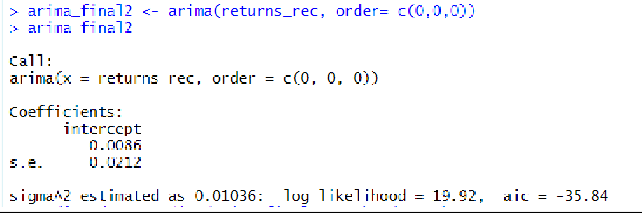

**Diagnostic Test**

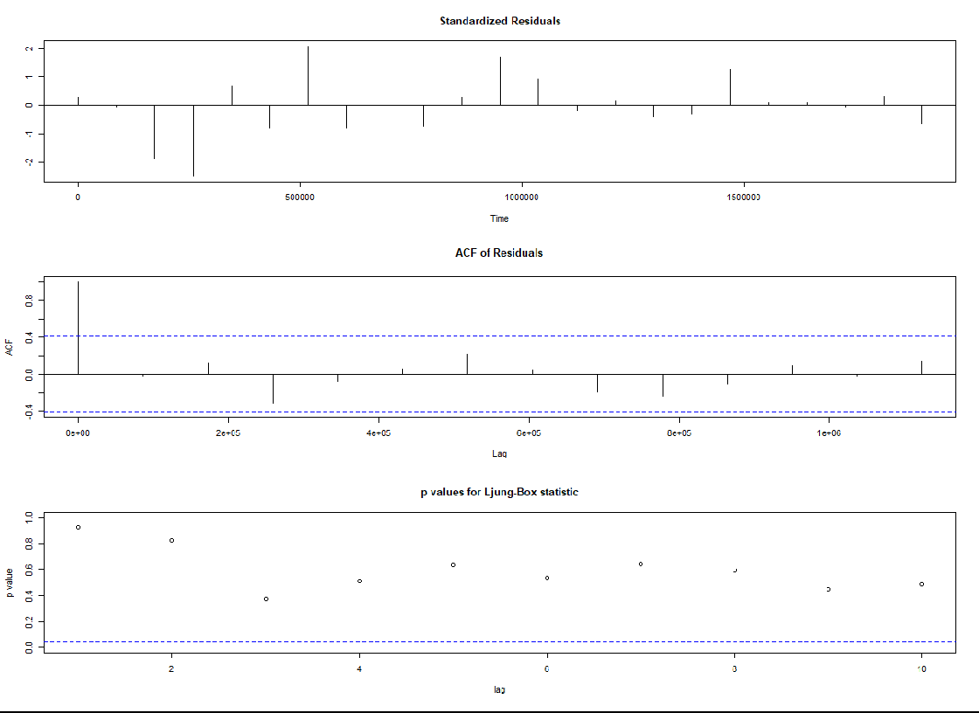

Diagnostic Test for Monthly Returns of Ultratech cement

**Interpretation:**

• Standardized Residuals of the model are randomly distributed.

• ACF of residuals is not significant for any value lag.

• The p-values for Ljung-Box is greater than 0.05

Therefore, we can conclude on the basis of above three observations that the model is a moderate fit.

**Prediction using the ARIMA model**

ARIMA Model Forecast for Monthly Returns of ultratech cement

This is something specific to a stable series. As already mentioned, historical data can lead to convergent future predictions only for stable data or for smoothened (differenced) data. The prediction interval has been decided by seeing when the forecast converges. This is because after running for some interval, the data series will converge at one value and the curve will stabilize

The forecast given by the model is given above.

**Forecasting Volatility using GARCH & EGARCH models** We run the GARCH models again on the daily returns of ultratech cement.

GARCH Specs for Monthly returns of ultratech cement

From the above table we see that GARCH (1,1) is the most appropriate model and by default the mean model ARFIMA(1,0,1) is chosen.

We run the EGARCH models again on the daily returns of ultratech cement.

EGARCH Model Specs for Monthly returns for ultratech cement

From the above table we see that EGARCH (1,1) is the most suitable model and by default the mean model ARFIMA(1,0,1) is chosen. These results are similar to what we observed for the GARCH model.

**Estimating the Model**

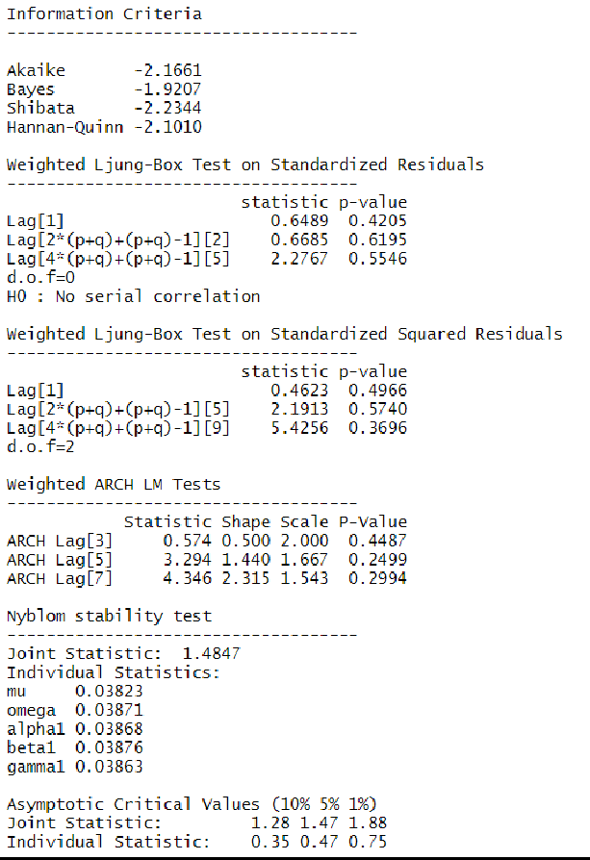

Diagnostic Test for Monthly Returns of ultratech cement

● In GARCH, the variance tends to show mean reversion which means it gets pulled to a long-term volatility rate over time.

● The conclusion obtained from the weighted Ljung-Box Test shows us that there is no relationship between the residuals and this is a stable model.

● Here Omega, Alpha and Beta are obtained from estimated standard errors in the figure above.

**GARCH Model Forecast:**

Now we use the GARCH Model to forecast volatility. The forecast are as follows:

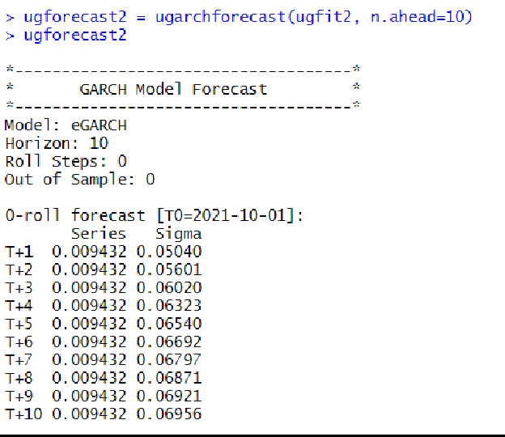

GARCH Model Volatility Forecast for Monthly Returns of ultratech cement

**CONCLUSION**

Ultratech cement is India’s largest manufacturer of grey cement Ready Mix Concrete (RMC) and white cement.It is also one of the leading cement producers globally .

The results from the company analysis done is given below:

● The beta from regression analysis between security’s returns (dependent variable) and market returns (independent variable) was performed, and beta obtained for different frequencies is given below

○ Daily returns Beta = 0.921

○ Weekly returns Beta = 0.955

○ Monthly returns Beta = 0.52

● ARIMA(0,0,0) model was found to be the best model to forecast returns for all the three frequencies and returns for next 10 time periods were forecasted using the model.

● GARCH(1,1) model was the best fit model to forecast conditional volatility for all the three frequencies and volatility of the next 10 time periods was forecasted using the model.